**Double Ring Intricate Floral Metal Wall Art**

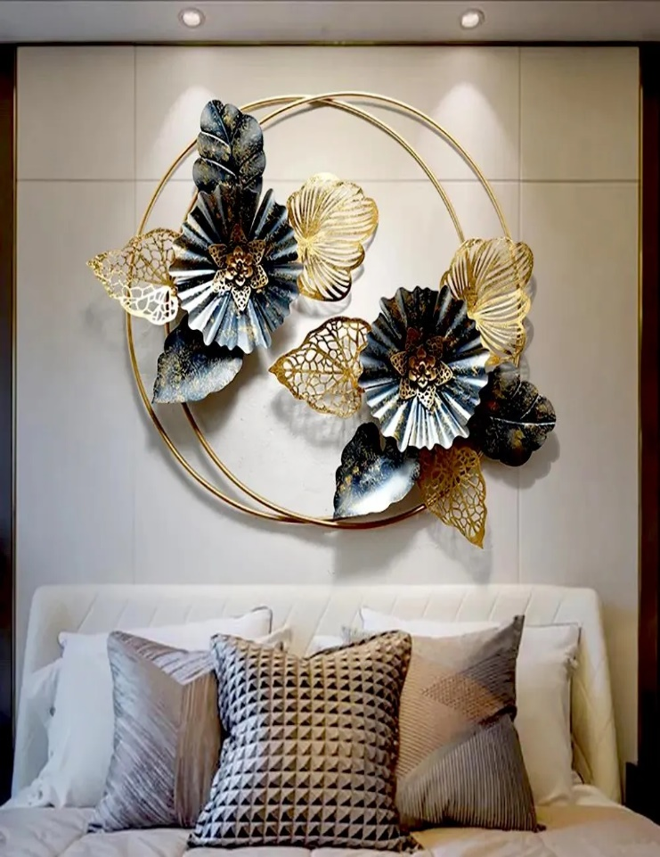Double ring intricate floral metal wall art is a captivating piece that combines elegance with artistic intricacy. Featuring two interlocking rings adorned with finely detailed floral patterns, this design symbolizes unity and harmony while showcasing exceptional craftsmanship. The metal construction, often finished in luxurious tones like gold, bronze, or matte black, adds durability and sophistication. Perfect for living rooms, bedrooms, or entryways, this wall art brings a touch of nature-inspired beauty to modern and classic interiors alike. Its timeless design and balanced composition make it a striking focal point that enhances the aesthetic appeal of any space.